**Wellbeing and Working at Home**

The objective of the online forum was to listen and respond to your concerns/questions, and provide essential support for you to the best of our abilities. The Faculty International Office understands that students may require further support, and so we have put together this document outlining some of the wellbeing support available online at the University and elsewhere.

**The most important thing to remember, even when self-isolating, is that there is still support available and you can still reach out for help if you need to.**

**How to access UoS wellbeing support:**

The early closure of teaching for the Easter break and the ongoing Coronavirus situation has been an unprecedented and difficult time for everyone. Enabling Services have a large amount of self-help resources available on their website, which you may wish to take a look at: <https://www.southampton.ac.uk/edusupport/index.page?>

If you would like to contact Enabling Services then they are still open, however please email [enable@soton.ac.uk](mailto:enable@soton.ac.uk). If you are facing significant difficulties or dealing with a crisis, please email [firstsupport@soton.ac.uk](mailto:firstsupport@soton.ac.uk).

For the latest advice and support from Enabling Services, please visit their news page: <https://www.southampton.ac.uk/edusupport/news/latest.page>

The Student Life Team are also continuing to support all students via email, regardless of where you are.  If you would like some support from Student Life please email [studentlife@soton.ac.uk](mailto:studentlife@soton.ac.uk).  If the situation is urgent then somebody from the Student Life team will phone you.

There is also a University of Southampton Student Life Facebook group for students to use: <https://www.facebook.com/UoSStudentLife/>

**Other wellbeing resources available:**

Students may benefit from visiting the Student Minds website to access the wellbeing support available: <https://www.studentminds.org.uk/>

There are also several services available via the phone, 24 hours a day, 365 days a year, such as the [Samaritans](https://www.samaritans.org/) and [SHOUT](https://www.giveusashout.org/).

There are also new services being set up, such as [The Help Hub](https://www.thehelphub.co.uk/) who are hoping to start running soon.  They will be offering free 20-minute online appointments to people who are self-isolating and struggling with their wellbeing.

There are also a number of NHS [apps](https://www.nhs.uk/apps-library/) available to download, some of which may be helpful for maintaining your routine and wellbeing.

**Another important thing to remember, is to take good care of yourself. The University has put together programmes of online activities, as well as offered helpful tips for this.**

**Join UoS Virtual Fitness and Wellbeing Sessions:**

Sport and Wellbeing have launched free virtual fitness and wellbeing classes for staff and students who are working from home during the COVID-19 pandemic.

Please click this link for more information: <https://www.southampton.ac.uk/sportandwellbeing/index.page>

You can watch and join in via [Facebook](https://www.facebook.com/SportWellUoS/).

Once the classes have aired, you can also find them on [YouTube](https://www.youtube.com/channel/UCTM76Exi3N7GUSOr5oh6IlQ).

**Self-care tips:**

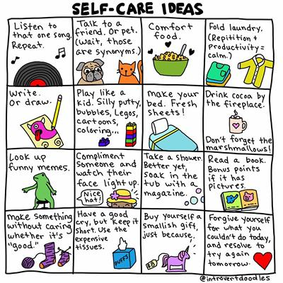

**SUSU offer students guidance:**

SUSU is working closely with the University to ensure the wellbeing of students and have compiled some FAQs to offer students guidance about the current situation: <https://www.susu.org/support/coronavirus.html>

SUSU also has created a Facebook group to offer support to students: <https://www.facebook.com/groups/2537991693135957>

Stay safe and take care.

Best wishes

The Faculty International Office Team